The New Colossus
By: Emma Lazarus
One of the first successful Jewish American authors, Lazarus was part of the late nineteenth century New York literary elite and was recognized in her day as an important American poet.
Her famous poem captured the nation's imagination and continues to shape the way we think about immigration and freedom today. Written in 1883, her celebrated poem, "The New Colossus," is engraved on a plaque in the pedestal of the Statue of Liberty. Her poem contrasts the Old World (Europe) and the New World (America) through a comparison of their colossal statues, the Colossus of Rhodes and the Statue of Liberty.
Not like the brazen giant of Greek fame,
With conquering limbs astride from land to land;
Here at our sea-washed, sunset gates shall stand
A mighty woman with a torch, whose flame
Is the imprisoned lightning, and her name
Mother of Exiles. From her beacon-hand
Glows world-wide welcome
her mild eyes command

The air-bridged harbor that twin cities frame.
“Keep, ancient lands,
your storied pomp!” cries she

With silent lips. “Give me your tired, your poor,
Your huddled masses yearning to breathe free,
The wretched refuse of your teeming shore.
Send these, the homeless, tempest-tost to me,
I lift my lamp beside the golden door!”

Words to Know
- Colossus: a statue or image of the human form of very large dimensions.
- Brazen: bold.
- Pomp: a stately, splendid, and perhaps indulgent display.
- Refuse: Something that is discarded as worthless or useless.
- Teeming: crowded.
- Tempest: a storm.

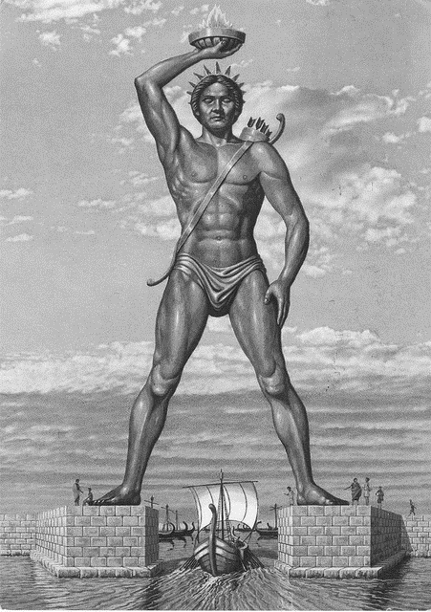
How are the two statues similar and different?

How does the title connect to the title of the poem, “The New Colossus”?

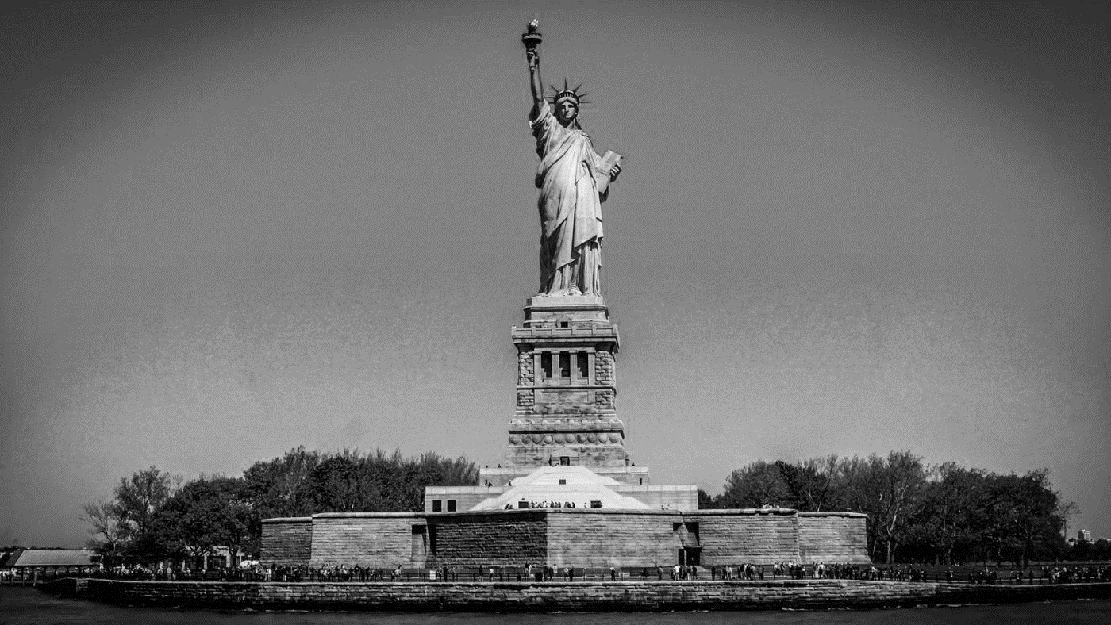
Colossus of Rhodes, ~304 BC

It’s All an Allusion
Statue of Liberty, 1886

Everything is an Allusion
Allusion: In literature, an allusion is when an author references a renowned or well-known person, place, or thing from history.
- Identify the allusion. Who or what is Lazarus referencing in lines 1-2 below?

“Not like the brazen giant of Greek fame.
with conquering limbs astride from land to land;

________________________________________________________________________

- Who is the “Mother of Exiles” (line 6)? ________________________________________ ________________________________________

- Read lines 10-13 below.

“Give me your tired, your poor,
Your huddled masses yearning to breathe free,
The wretched refuse of your teeming shore.
Send these, the homeless, tempest-tost to me,...”

Who is the speaker in line 10? ____________________________________________

Who are the “tired,” “poor,” and “homeless”? _____________________________________________________________________
_____________________________________________________________________
- The statue stands in the harbor (between the twin cities of Brooklyn, then a separate city, and New York) bridging the waters between the Old World and the New. What does she want from the Old World? What does she reject? What does she offer to "the wretched refuse" (poor immigrants)?
________________________________________________________________________________________________________________________________________________________________________________________________________________________________________________________________________________________________
Jewish Daily Forward
Headline
Lady Liberty: Symbol of Refuge and Freedom
Guiding Questions:
How does the poet’s choice of words in her poem suggest that the Statue of Liberty is symbol of refuge and freedom? Use text details to support your answers.

